

ANIMAL PRODUCTION SYSTEMS

Stage 2 Draft Sample Examination

Section 7 of the WACE Manual: 2008 Revised Edition outlines the policy on WACE examinations.

Further information about the WACE Examinations policy can be accessed from the Curriculum Council website at http://www.curriculum.wa.edu.au/

The purpose for providing a sample examination is to provide teachers with an example of how the course will be examined. Further finetuning will be made to this sample in 2008 by the examination panel following consultation with teachers, measurement specialists and advice from the Assessment, Review and Moderation (ARM) panel.

2008/23053



Western Australian Certificate of Education, Draft Sample External Examination
Question/answer booklet

Animal Production
Please place your student identification label in this box
Systems
Written paper
Stage 2

Student Number: In figures

In words

Time allowed for this paper
Reading time before commencing work: Ten minutes
Working time for paper: Three hours

Materials required/recommended for this paper
To be provided by the supervisor
Question/answer booklet
Extended answer booklet
Separate multiple choice answer sheet

To be provided by the candidate
Standard items: pens, pencils, eraser or correction fluid, ruler, highlighter
Special items: calculator

Important note to candidates
No other items may be taken into the examination room. It is your responsibility to ensure that you do not have any unauthorised notes or other items of a non-personal nature in the examination room. If you have any unauthorised material with you, hand it to the supervisor before reading any further.

Structure of this paper

Sections | Number of questions available | Number of questions to be attempted | Suggested working time (minutes) | Marks available
ONE  Multiple choice | 20 | 20 | 30 | 20
TWO  Short response | 6 | 6 | 70 | 70
THREE  Production practices response | 1 | 1 | 20 | 20
FOUR  Extended response | 4 | 2 | 60 | 40
 |  | Total marks |  | 150

Instructions to candidates
- The rules for the conduct of the Western Australian external examinations are detailed in the TEE/WACE Handbook. Sitting this examination implies that you agree to abide by these rules.

Section One—Multiple-choice 20 marks

There are Twenty (20) questions in this section. Attempt all questions.

Mark your answers to questions 1–20 on the separate multiple choice answer sheet using a 2B, B or HB pencil.

Allow approximately 30 minutes for this section.

- Which of the following is NOT a basic requirement for the welfare of animals?
[1 mark]

(a) livestock being economically viable
- livestock being protected from predators
- livestock having access to sufficient water
- livestock having an adequate level of nutrition.

- Which of the following classes of livestock is most affected by wind chill exposure?
[1 mark]
(a) adult livestock
- newborn livestock
- livestock following marking
- livestock following weaning.
[From: Board of Studies New South Wales, 2005]

- An employee arrives at work to find an item of equipment with a safety tag attached. The tag states ‘DO NOT OPERATE’. Which procedure should be followed?
[1 mark]
- remove the tag, check the equipment and then operate the equipment
- leave the tag in place and inform the supervisor that you are using the equipment
- leave the tag in place, check the equipment for faults and then operate the equipment
- leave the tag in place and look for alternative equipment to do the job.

[From: Board of Studies New South Wales, 2005]

- The mammary glands are important for:
[1 mark]
- circulation
- excretion
- digestion
- lactation.

- A co-dominant genetic condition is one in which:
[1 mark]
- there are two possible ways to combine alleles
- the homozygote has inherited different alleles from each parent
- the heterozygote shows the effect of two different alleles
- one allele completely hides the effect of another allele.

- Mitosis is the division of a cell’s nucleus into two daughter nuclei. Which of the following statements about mitosis is correct?
[1 mark]
- the two daughter nuclei each carry half as many chromosomes as the original nucleus
- the DNA in each of the daughter nuclei is an identical copy of the DNA in the original nucleus
- each daughter nucleus carries twice as much DNA as the original nucleus
- the two daughter nuclei each have twice as many chromosomes as the original nucleus.

- Which of the following statements about cell division is most correct?
[1 mark]
- mitosis occurs during asexual reproduction
- meiosis begins immediately after fertilisation
- mitosis explains why three brothers do not look alike
- meiosis involves mutation of chromosomes.

- Which of the following statements is true of natural ecosystems?
[1 mark]
- energy recycles within natural ecosystems
- nutrients flow through natural ecosystems
- natural ecosystems do not include living and non-living components
- there is no heat energy loss from natural ecosystems.

- Refer to the following graph to answer the question which follows. Note: The focus of this question is to determine your ability to interpret the graph, not the actual breeding cycles of sheep and poultry.
[1 mark]

Breeding cycle of Merino sheep and poultry
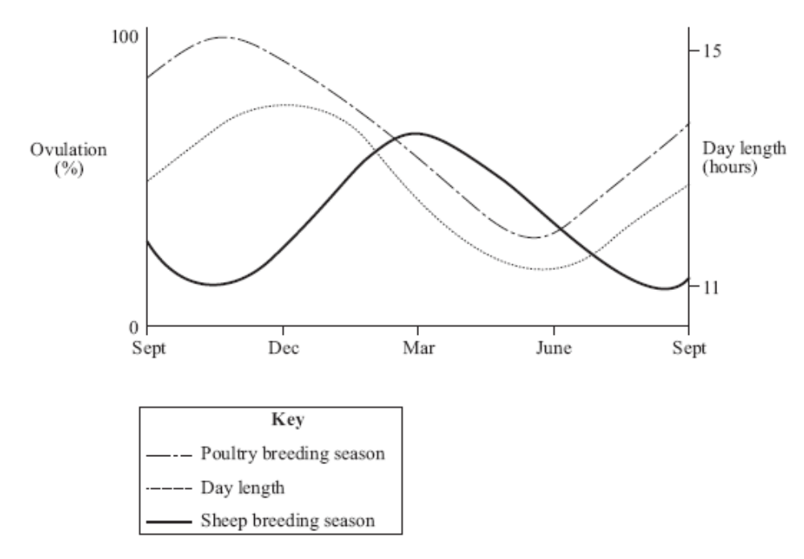

Which of the following combinations of events is correct?

 | Breeding trigger for merino | Replace poultry stock with low egg output
a | short day length | June
b | melatonin | September
c | increasing day length | December
d | decreasing melatonin level | April

[Adapted from: Senior Secondary Assessment Board of South Australia, 2004]

- What is the main purpose of calibrating a chemical applicator?
[1 mark]
- to ensure that the recommended rate of chemical is being applied
- to ensure that the concentration of chemical in the tank is correct
- to ensure that the traveling speed of the sprayer is appropriate
- to ensure that the spray height allows optimal chemical coverage.

- Refer to the following graph, which shows the muscle, fat, and bone growth relative to live weight of Friesian heifers, steers and bulls, to answer the question that follows.
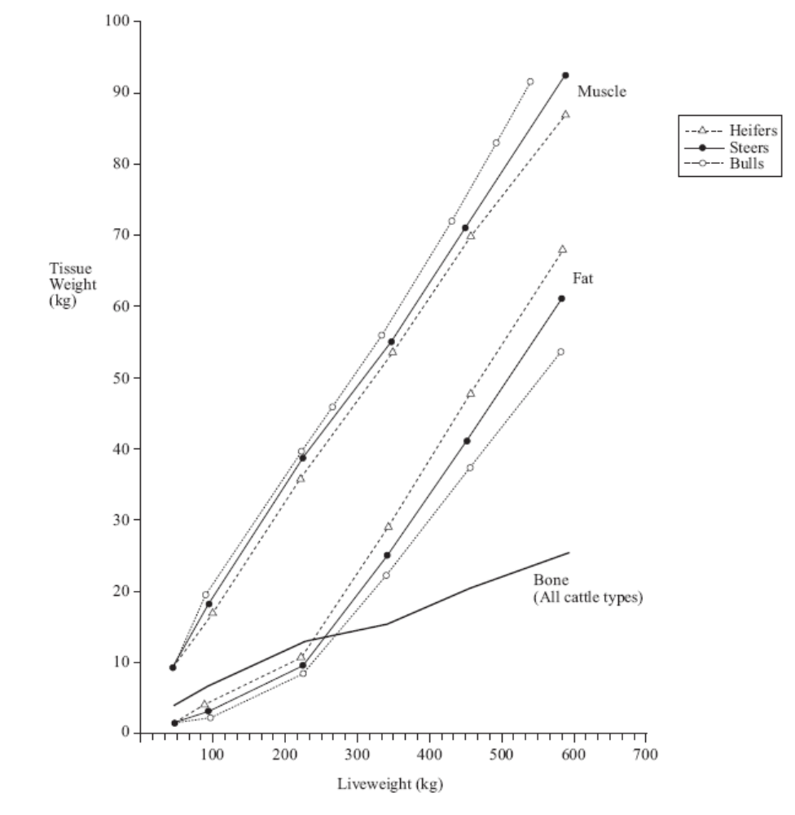
Which of the following statements, a, b, c or d, is best supported by the graph?
[1 mark]
- bulls of 300 kg have greater muscle tissue than 330 kg steers
- steers at lower weights tend to have a higher muscle-to-bone ratio than steers at higher weights
- male cattle have consistently lower fat content at all live weights compared to female cattle
- the ratio of muscle weight to bone weight is higher in steers than it is in bulls.

[Adapted from: Senior Secondary Assessment Board of South Australia, 2004]

- Refer to the following table, which shows the protein and fat content of milk, based on a study of four breeds of dairy cattle:

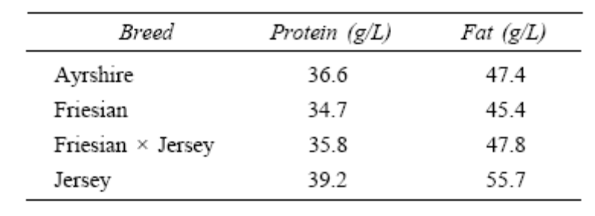
What conclusion can be drawn from the data in the table above?
[1 mark]
- Friesian × Jersey cattle will produce milk with levels of protein and fat midway between those of Friesian cattle and Jersey cattle.
- the mean amount of milk protein for the four breeds is 35.7 g/L.
- Ayrshire cattle are less efficient than cross-bred cattle at producing milk protein.
- the infusion of the Jersey breed into Friesian dairy herds will improve both protein and fat content of milk.
[Adapted from: Senior Secondary Assessment Board of South Australia, 2005]

- Which one of the following combinations, a, b, c or d, best describes the breeding cycles of farm animals?
[1 mark]

 | Seasonally polyoestrous | Polyoestrous | Mono-oestrous
a | mare | sow | ewe
b | ewe | mare | doe
c | doe | sow | kelpie bitch
d | cow | ewe | sow

[Adapted from: Senior Secondary Assessment Board of South Australia, 2005]

- What information about a chemical is provided by its Material Safety Data Sheet (MSDS)?
[1 mark]
- hazards, precautions for use, cost of the chemical composition
- composition, hazards, safe handling and first aid procedures
- precautions for use, hazards, first aid procedures and reputable supplier
- safe handling, suitable alternative chemicals, first aid procedures and composition.

- A researcher devised a trial to compare the egg-laying rate of hens in a number of pens with different stocking rates. The results were analysed, and there was no significant difference in the number of eggs laid in the different pens. However, the researcher noted that the egg shells appeared to be thinner in pens with a high stocking rate. She wrote this into her conclusions, citing as proof the larger number of broken eggs in these pens.

Which of the following suggests why this is an inappropriate conclusion?
[1 mark]

- she did not take objective measurements in relation to her conclusions
- she did not control all the variables that might have affected the number of broken eggs
- she did not analyse the shell thickness
- all of the above.

- The graph below shows the lethal dose to 50% of rats (LD50) for some chemical compounds.

Which of the following alternatives correctly lists chemical compounds from least toxic to most toxic?
[1 mark]
- caffeine, aspirin, common salt, simazine
- aspirin, atrazine, bromolynil, caffeine
- paraquat, aspirin, MCPA, chlorosulfuron
- glyphosate, atrizine, caffeine, paraquat.

[From: Board of Studies New South Wales, 2004]

- Using the information provided in the table below, determine the cost of diesel fuel for one week of harvesting.
[1 mark]

Implement | Fuel type | Fuel cost  (cents/litre) | Usage rate  (litres/hour) | Usage  (hours/week)
Truck | Diesel | 90 | 5 | 40
Tractor | Diesel | 90 | 6 | 20
Header | Diesel | 90 | 10 | 50

- $620.00
- $738.00
- $820.00
- $7380.00

[From: Board of Studies New South Wales, 2004]

- The table below shows the cost per pack of four different agricultural products.

 | Product A | Product B | Product C | Product D
Pack size | 15 litre | 5 litre | 5 litre | 20 litre
Application rate (per unit) | 35 mL | 36 mL | 20 mL | 75 mL
Cost per pack | $1325.00 | $563.00 | $766.00 | $616.00

Which product is the most expensive per dose?
[1 mark]
- product A
- product B
- product C
- product D.

[From: Board of Studies New South Wales, 2005]

- An enterprising farmer plans to start a new business raising crocodiles for leather. The plan is to feed chickens to the crocodiles. When a crocodile is killed for its skin, the body will be dried and crushed to produce chicken feed. The farmer believes that this will be a self-sustaining system where no money is spent on food for either the crocodiles or the chickens. Which of the following statements about the plan is most correct?
[1 mark]
- The plan will succeed because there is complete recycling
- The plan will succeed because both crocodiles and chickens will have high protein diets
- The plan will fail because energy conversion in feeding relationships is not 100% efficient
- The plan will fail because both the crocodiles and chickens are consumers.

- A farmer observes that the volume of milk produced by each cow in a herd is different. To identify the reasons for this variation the farmer decides to record the observations for a period of time. A summary of the average results is shown in the table below.

Breed of cow | Diet | Average milk production  (L/day/cow)
Freisian | Grain fed | 38
Freisian | Grass fed | 32
Jersey | Grain fed | 31
Jersey | Grass fed | 26

Which of the following conclusions regarding these observations is most likely to be correct?
[1 mark]

- the volume of milk produced is influenced by genes and environment
- the volume of milk produced is influenced by genes alone
- the volume of milk produced is influenced by environment alone
- the volume of milk produced is influenced by many random factors.

END OF SECTION ONE

Section Two—Short Response 70 marks

There are six (6) questions in this section. Attempt all questions.

Answer all questions in this section in the spaces provided.

Allow approximately 70 minutes for this section

Question 1 12 marks
[Adapted from: Senior Secondary Assessment Board of South Australia, 2005]

An experiment was conducted to determine the effect of progesterone on the length of the
oestrous cycle in a female animal. Subcutaneous injections at four dose levels were administered daily for 4 days, starting on the first day of oestrus. Eight animals were tested at each dose level. The results are shown in the table below:

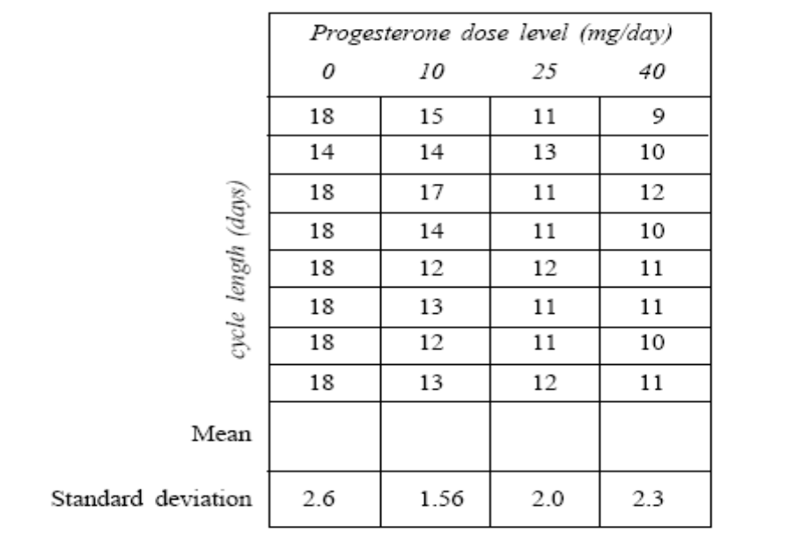
Average

- Calculate the average (mean) cycle length (days) for each dose level. Write your answers in the spaces provided in the table above.
[4 marks]

- On the axes below, plot and join the points to form a graph of the means.
[1 mark]

Effect of progesterone on length of the oestrous cycle
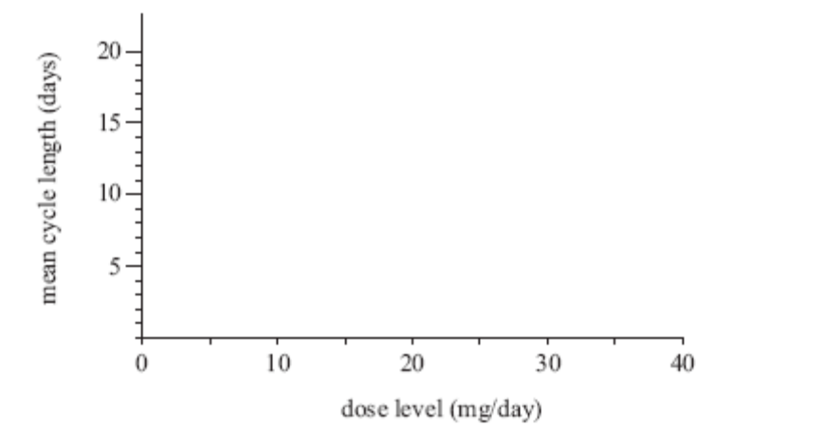

- State and explain two components of the experimental design that should be considered to ensure minimal variation in this experiment.

Component 1:
[2 marks]

Component 2:
[2 marks]

- State an appropriate hypothesis for this experiment.
[1 mark]

(e) State and explain the two conclusions that can be drawn from the results of the experiment.
[2 marks]
(i)

(ii)

Question 2 12 marks

[Adapted from: Board of Studies New South Wales, 2006]

The following graph shows the recommended metabolisable energy (ME) levels required and measured in mega joules per kilogram of dry matter (MJ/kg DM), for a breeding animal during a production cycle.
Recommended metabolisable energy (ME) levels for a breeding animal.
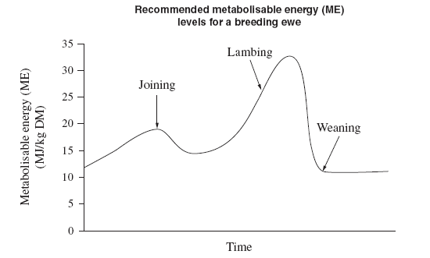

Birth

- Identify and explain the trend observed in the graph for the ME levels leading up to birth.
[4 marks]

- State, giving a reason, one management practice to increase fertility. At what stage of the production cycle should this occur, give reasons?
[4 marks]

- State and explain how two factors, other than nutrition, may affect the fertility of farm animals.
[4 marks]

Question 3 [10 marks]

[Adapted from: Senior Secondary Assessment Board of South Australia, 2005]

Refer to the following diagrams of digestive systems of three common farm animals.

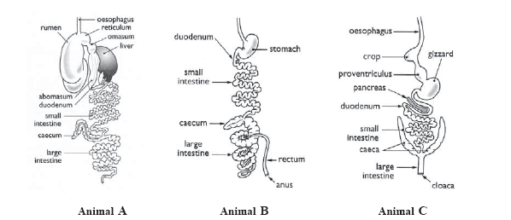
[Diagrams from: Brown, Hindmarsh & McGregor, 2001]

- Identify the type of digestive system of animal A, and give one example of a farm animal that has this system.
[2 marks]
Digestive system animal A:
Example:

- Outline and explain the function and physiology of the rumen-reticulum in the digestive system of animal A.
[4 marks]

- Name and describe the unique feature of the digestive system of animal C that enables it to use its food source, and state the type of animal where it is found.
[3 marks]

- Give the name of one farm animal that has the digestive system represented by animal B
[1 mark]

Question 4 12 marks
[Adapted from:Board of Studies New South Wales, 2006]

Refer to the Duracide label provided to answer parts (a) to (c).

Identify from the label, two types of safety equipment that must be worn when preparing the treatment.
[2 marks]

  - Explain the process (in three main steps) you would take to treat a mob of sheep with Duracide. Assume you are wearing protective clothing and the sheep are already mustered into the yards.
[6 marks]
Step 1:

Step 2:

Step 3:

  - State and explain two consequences of how incorrect usage of agricultural chemicals may affect farm production systems.
[4 marks]

Duracide Label

SUSTAINED ACTION SPRAY-ON LICE TREATMENT FOR SHORN SHEEP

Provides 10 weeks protection against reinfestation with susceptible body lice.

DIRECTIONS FOR USE (all states)
RESTRAINTS.
DO NOT use on sheep that have not been closely shorn (eg. because of mycotic dermatitis).

ANIMAL | PEST | RATE |  | CRITICAL COMMENTS
 |  | Basic dose rate is 4mg Alpha-Cypermethrin per kg body weight. (1mL per 5kg bodyweight)
 |  | Bodyweight | Dose Volume
Sheep | Body Lice (Damalinia ovis) | Under 20 kg  21 to 50 kg  51 to 70 kg | 5 mL  10 mL  15 mL | For application to sheep shorn within 24 hours prior to treatment.  Apply DURACIDE along the backline of the sheep ensuring equal deposit on either side of the backline. The spray band should be approximately 12 cm in width.

Sheep over 70kg should be dosed at the rate of 1mL per 5kg body weight. Treat according to heaviest animal in mob. Animals should be weighed.

NOT TO BE USED FOR ANY PURPOSE, OR IN ANY MANNER CONTRARY TO THIS LABEL UNLESS AUTHORISED UNDER APPROPRIATE LEGISLATION.

WITHHOLDING PERIOD NIL
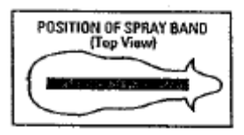

GENERAL INSTRUCTIONS
- Shake well before use.
2. Estimate weights of sheep and set applicator to deliver appropriate dose for the heaviest sheep in the race. Use only the DURACIDE applicator.
3. Attach DURACIDE applicator to back pack or drum and prime ready for use by squeezing the trigger until delivery tube and applicator are full.
4. DURACIDE can be used at the same time as other management practices but it is recommended that DURACIDE is the last treatment before sheep are returned to paddocks.
5. A scourable green pigment is included in DURACIDE for identification of treated sheep.
6. After all sheep are treated or at the end of each day’s work, disconnect the DURACIDE applicator from the back pack or drum and seal the container tightly
Wash DURACIDE applicator in cold water.
7. Alpha-cypermethrin is a synthetic pyrethroid compound.
8. DURACIDE can be applied to wet sheep.

LIMITATIONS
Up to 6 weeks are required for this product to kill lice on treated sheep. Live lice on ewes treated within 6 weeks of lambing can infest the lambs born of these ewes. To avoid possible breakdowns, do not treat ewes later than 6 weeks before lambing. Breakdowns are also likely to occur when ewes are treated with lambs at foot.

PROTECTION OF WILDLIFE, FISH, CRUSTACEA AND ENVIRONMENT
Dangerous to fish. Do not contaminate dams, rivers or streams pit away from watercourses. Destroy empty containers by crushing and bury at a depth of 500mm or more at a licenced/approved disposal site. In some States wastes can only be buried at a licenced landfill.

SAFETY DIRECTIONS
Harmful if swallowed. May irritate the eyes and skin. Facial skin contact may cause temporary facial numbness. Avoid contact with eyes and skin.
Avoid inhaling spray mist when applying. Wear cotton overalls buttoned to the neck and wrist and washable hat and elbow length PVC gloves. Wash hands after use. After each day’s use wash gloves and contaminated clothing.

FIRST AID
If poisoning occurs, contact a doctor or Poisons Information Centre. If swallowed, and if more than 15 minutes from a hospital, induce vomiting preferably using Ipecac Syrup APF.

Registered under:
Stock Medicines Act, 1939 (SA)
Veterinary Medicines Act, 1987 (Tas)

Storage:
Store below 30ºC (Room temperature).
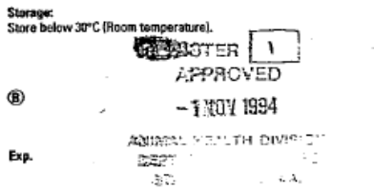

SmithKline Beecham Animal Health
A division of SmithKline Beecham (Australia) Pty. Limited
Warringah Road, Frenchs Forest, NSW, 2086

® Registered Trademark

Question 5 [12 marks]
[Adapted from: Board of Studies New South Wales, 2002]

(a) Name one animal farm product you have studied.
[1 mark]

Name of farm product:

- Identify one criterion for assessing the quality of the product.
[1 mark]

- List and give reasons for three actions a farmer may take to maximise the quality of the product before it leaves the farm.
[6 marks]

- Name an organisation that contributes to the marketing of the product by outlining their responsibility, aim, and how the aim is achieved.
[4 marks]
Name of organisation:

Responsibility:

Aim:

How aim is achieved:

Question 6 [12 marks]

Refer to the following information which describes an hypothetical scenario, to answer the questions that follow:

Mannosidosis is a genetic disease that has lethal effects in Aberdeen Angus cattle; calves with this disease rarely reach the age of 3 months.

An Aberdeen Angus breeder found that this disease occurred in a drop of calves after he had inseminated his entire 256-cow herd with semen from an overseas sire. Fifty-three calves died of the disease. Five years before this he had replaced his whole herd, using the semen of a bull from the same stud bloodline.

- Mannosidosis is a recessive gene. The cattle who do not display Mannosidosis are homozygous (MM).

Using the punnet square below, show how the genotype and phenotype of the newly imported semen created this problem.

BULL gametes
COW gametes

Genotype of cow: [1 mark]

Phenotype of cow: [1 mark]

Genotype of bull: [1 mark]

Phenotype of bull: [1 mark]

Percentage chance of calves with the disease: [1 mark]

Percentage chance of calves without the disease: [1 mark]
- Describe in genetic terms how this problem occurred, and suggest a solution.
[6 marks]

END OF SECTION TWO
Section Three—Production practices response 20 marks

There is one (1) question in this section.

Allow approximately 20 minutes to complete this section.

Question 7 20 Marks

[Adapted from: Victorian Curriculum and Assessment Authority, 2003]

Select an enterprise type you have studied to answer the questions below. Some examples have been listed.

Examples of enterprises include:

- Fish or yabby breeding and/or production
- Managing poultry for fresh eggs or meat production
- Breeding and/or rearing cattle for the beef or dairy market
- Breeding and/or rearing sheep for wool and/or meat market
- Breeding and/or rearing pigs for the meat market

- State an enterprise and end product you have studied.
[1 mark]

- List five activities in the production process of animal products for market or use.
[5 marks]

- Select one of the activities you have listed in part (b). Describe how two items of specialised equipment or machinery have improved production outputs.
[4 marks]

- Select one of the activities listed in part (b), and describe two ways in which profitability has been improved.
[4 marks]

- Define sustainability and describe how it can be improved for one of the activities you listed in part (b).
[6 marks]

END OF SECTION THREE

Section Four—Extended Response 40 marks

There are four (4) questions in this section.

Answer any two of the following questions in the separate answer booklet provided.

Allow approximately 70 minutes to complete this section

Question 8 20 marks

Animal pests and diseases can be responsible for significant economic loss.
- List and describe three common methods available to control animal pests and diseases.

- Explain how you could identify one pest or disease, how it is contracted, and the consequences of the pest or disease on an animal production system you have studied.

Question 9 20 marks

Describe and discuss the benefits of three different breeding systems in an enterprise of your choice. How can these breeding systems improve animal production?

Question 10 20 marks

Describe three factors that impact on the profitability of a farm business. For each of these factors:

- Explain how the farm manager’s decisions can address each factor to maintain profitability.
- Discuss how these decisions may affect the long-term sustainability of the farm.
[From: Board of Studies New South Wales, 2004]

Question 11 20 marks

Efficient animal growth and optimum development are essential aims for all profitable animal enterprises. For a farm animal you have studied:

- Describe optimal growth and development of your chosen animal by labelling the graph of live weight against time, at points A-D, and explain the shape of the curve.

Generalised growth curve of an animal

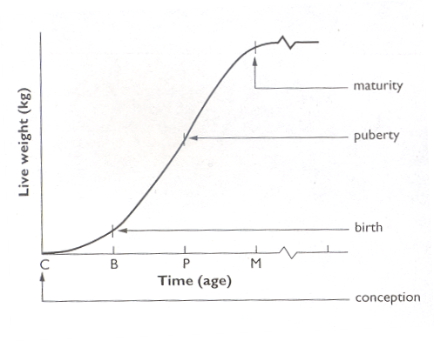
A_________________________

C_____________

D_____________
B____________________

[Graph from: Brown, L., Hindmarsh, R., & McGregor, R. (2001). Dynamic agriculture: Book 3 (2nd ed.). Sydney: McGraw-Hill]

- Define genetic potential. Describe how management can manipulate three factors of the animal’s environment so that it can reach its genetic potential.

END OF PAPER
ACKNOWLEDGEMENTS

SECTION ONE

Question 2: Board of Studies New South Wales. (2005). Primary Industries: 2005 Higher School Certificate Examination (p. 3). Retrieved October, 2007, from http://www.boardofstudies.nsw.edu.au/hsc_exams/hsc2005exams/pdf_doc/primary_ind_vet_05.pdf.
© Board of Studies NSW for and on behalf of the Crown in right of the State of New South Wales.

Question 3: Board of Studies New South Wales. (2005). Primary Industries: 2005 Higher School Certificate Examination (p. 7). Retrieved October, 2007, from http://www.boardofstudies.nsw.edu.au/hsc_exams/hsc2005exams/pdf_doc/primary_ind_vet_05.pdf.
© Board of Studies NSW for and on behalf of the Crown in right of the State of New South Wales

Question 9: Adapted from: Senior Secondary Assessment Board of South Australia. (2004). 2004 Agricultural and Horticultural Science: public examination 2004 (p. 11). Retrieved October, 2007, from http://www.ssabsa.sa.edu.au/docs/ex-2004/2ags-ex-2004.pdf.

Question 11: Adapted from: Senior Secondary Assessment Board of South Australia. (2004). 2004 Agricultural and Horticultural Science: public examination 2004 (p. 10). Retrieved October, 2007, from http://www.ssabsa.sa.edu.au/docs/ex-2004/2ags-ex-2004.pdf

Question 12: Adapted from: Senior Secondary Assessment Board of South Australia. (2005). 2005 Agricultural and Horticultural Science: External examination 2005 (p. 4). Retrieved October, 2007, from http://www.ssabsa.sa.edu.au/docs/ex-2005/2ags-ex-2005.pdf.

Question 13: Adapted from: Senior Secondary Assessment Board of South Australia. (2005). 2005 Agricultural and Horticultural Science: External examination 2005 (p. 10). Retrieved October, 2007, from http://www.ssabsa.sa.edu.au/docs/ex-2005/2ags-ex-2005.pdf.

Question 16: Board of Studies New South Wales. (2004). Primary Industries: 2004 Higher School Certificate Examination (p. 6). Retrieved October, 2007, from http://www.boardofstudies.nsw.edu.au/hsc_exams/hsc2004exams/pdf_doc/primary_ind_vet_04.pdf.
© Board of Studies NSW for and on behalf of the Crown in right of the State of New South Wales

Question 17: Board of Studies New South Wales. (2004). Primary Industries: 2004 Higher School Certificate Examination (p. 6). Retrieved October, 2007, from http://www.boardofstudies.nsw.edu.au/hsc_exams/hsc2004exams/pdf_doc/primary_ind_vet_04.pdf.
© Board of Studies NSW for and on behalf of the Crown in right of the State of New South Wales

Question 18: Board of Studies New South Wales. (2005). Primary Industries: 2005 Higher School Certificate Examination (p. 6). Retrieved October, 2007, from http://www.boardofstudies.nsw.edu.au/hsc_exams/hsc2005exams/pdf_doc/primary_ind_vet_05.pdf.
© Board of Studies NSW for and on behalf of the Crown in right of the State of New South Wales

SECTION TWO

Question 1: Adapted from: Senior Secondary Assessment Board of South Australia. (2005). 2005 Agricultural and Horticultural Science: External examination 2005 (pp. 14–15). Retrieved September, 2007, from http://www.ssabsa.sa.edu.au/docs/ex-2005/2ags-ex-2005.pdf.

Question 2: Adapted from: Board of Studies New South Wales. (2006). Agriculture paper 1: 2006 Higher School Certificate Examination (pp. 10–11). Retrieved September, 2007, from http://www.boardofstudies.nsw.edu.au/hsc_exams/hsc2006exams/pdf_doc/agricult_p1_p2_06.pdf.
© Board of Studies NSW for and on behalf of the Crown in right of the State of New South Wales

Question 3: Adapted from: Senior Secondary Assessment Board of South Australia. (2005). 2005 Agricultural and Horticultural Science: External examination 2005 (p. 23). Retrieved September, 2007, from http://www.ssabsa.sa.edu.au/docs/ex-2005/2ags-ex-2005.pdf.

Diagrams from: Brown, L., Hindmarsh, R., & McGregor, R. (2001). Dynamic agriculture: Book 3 (2nd ed.). Sydney: McGraw-Hill, pp. 104,106. Retrieved September, 2007, from Senior Secondary Assessment Board of South Australia website: http://www.ssabsa.sa.edu.au/docs/ex-2005/2ags-ex-2005.pdf.

Question 4: Adapted from: Board of Studies New South Wales. (2006). Agriculture paper 1: 2006 Higher School Certificate Examination (pp. 14–15). Retrieved September, 2007, from http://www.boardofstudies.nsw.edu.au/hsc_exams/hsc2006exams/pdf_doc/agricult_p1_p2_06.pdf.
© Board of Studies NSW for and on behalf of the Crown in right of the State of New South Wales

Product label from: SmithKline Beecham Animal Health.

Question 5: Adapted from: Board of Studies New South Wales. (2002). Agriculture paper 1: 2002 Higher School Certificate Examination (p. 2). Retrieved September, 2007, from http://www.boardofstudies.nsw.edu.au/hsc_exams/hsc2002exams/pdf_doc/agricult_p1_02.pdf.
© Board of Studies NSW for and on behalf of the Crown in right of the State of New South Wales

SECTION THREE

Question 7: Adapted from: Victorian Curriculum and Assessment Authority. (2003). Agricultural and Horticultural Studies: Written examination: Victorian Certificate of Education 2003 (pp. 12–13). Retrieved September, 2007, from http://www.vcaa.vic.edu.au/vce/studies/agrihorculture/pastexams/2003_aghort.pdf.

SECTION FOUR

Question 10: Board of Studies New South Wales. (2004). Agriculture paper 1: 2004 Higher School Certificate Examination (p. 17). Retrieved September, 2007, from http://www.boardofstudies.nsw.edu.au/hsc_exams/hsc2004exams/pdf_doc/agricult_p1_04.pdf.
Published by the Curriculum Council of Western Australia
27 Walters Drive
OSBORNE PARK WA 6017
© Board of Studies NSW for and on behalf of the Crown in right of the State of New South Wales

